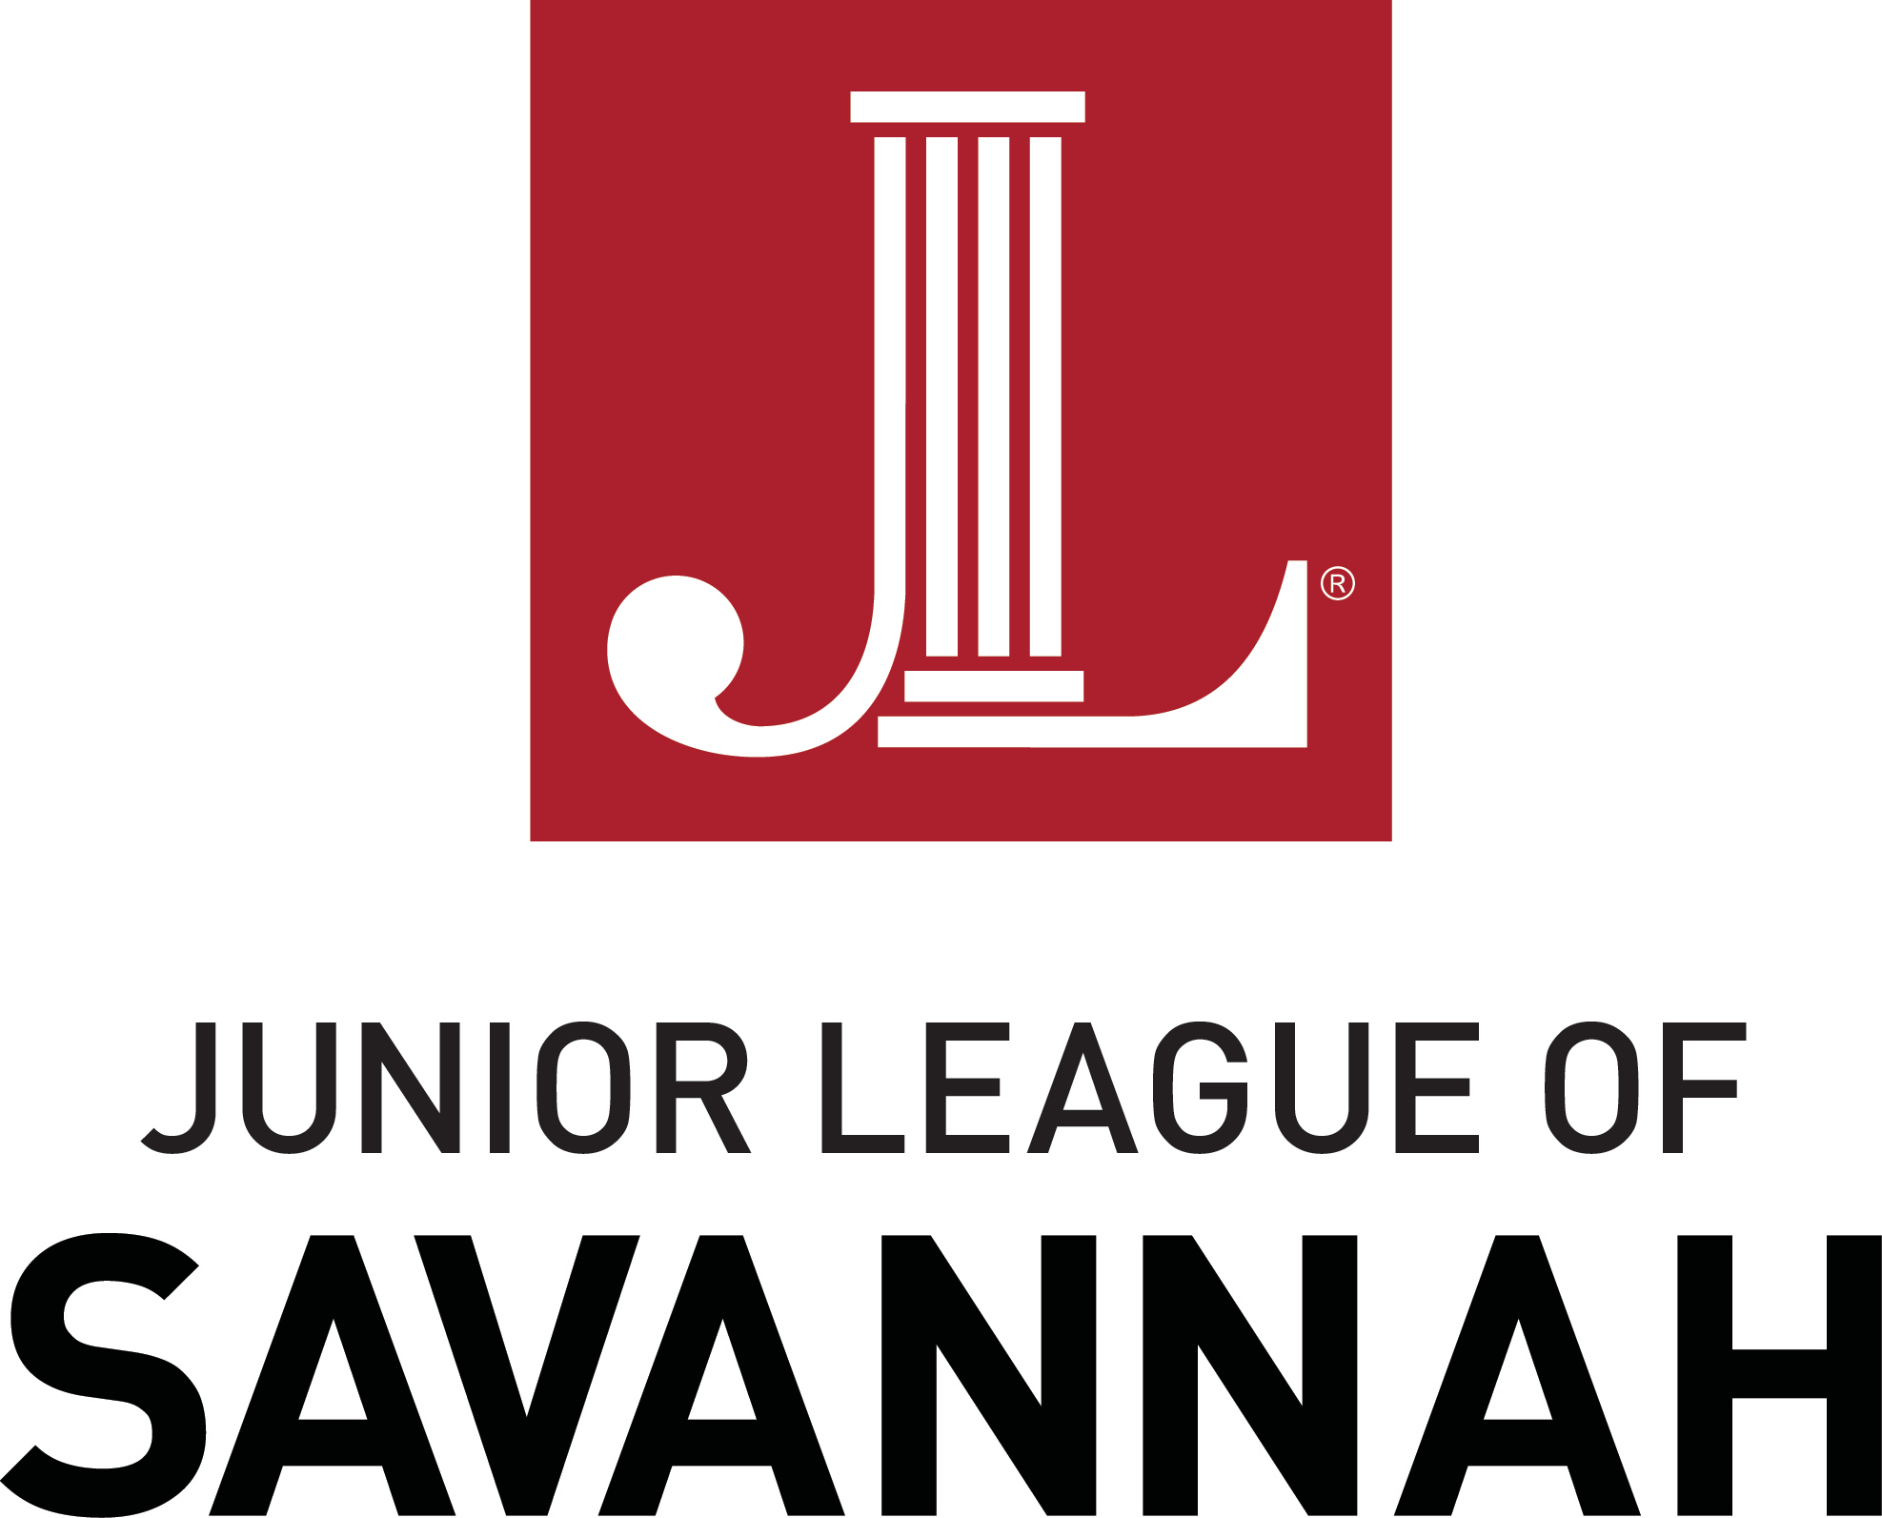

NEW MEMBER APPLICATION PACKET PROVISIONAL CLASS 2022-2023

Application Deadline: June 30, 2022

A complete application includes the following:
- Membership Application Form
- Acknowledgment of Provisional Member Obligations
- Code of Conduct Acceptance
- Attendance at a Recruitment Social or a completed Proposer Form
- Check payable to JLS for Course Fee and Dues in the amount of $350.00

Please return your completed application packet to:

Email to:

Erin Curran, Provisional Chair
renegade1993@gmail.com
OR
Mail to:
The Junior League of Savannah c/o Provisional Committee
P.O. Box 13268
Savannah, GA 31416

OR

Deliver to mail slot at:
Junior League of Savannah Headquarters 7706 Waters Avenue
Savannah, GA 31406

For questions concerning the Admissions Process or Provisional Course, please contact: Erin Curran, Provisional Chair
954-242-3698
renegade1993@gmail.com

2022-2023 Membership Application

Name:
(Last, First, Middle/Maiden)

Prefix: Miss Ms. Mrs.

Name as you would like it to appear on name tag: Spouse's Name (if applicable): Names/Ages of Children (if applicable):
Address:
(Street)

(City, State, Zip Code)

Phone Number(s):
(Please indicate if home, cell, or work)

Email: Date of Birth:

Highest Level of Education or Degree:

Present Occupation and Employer:

Other Volunteer & Leadership Involvement:

NEW MEMBER RECRUITMENT INFORMATION

Our Mission:
The Junior League of Savannah is an organization of women committed to promoting voluntarism, developing the potential of women, and improving communities through the effective action and leadership of trained volunteers. Its purpose is exclusively educational and charitable.
Member Obligations:
- Time Requirements:
  - Provisional Retreat: Attend the Provisional Retreat, scheduled for Saturday, August 13th from 10am-2pm.
  - Provisional Training Meetings: Attend a minimum of 7 monthly Provisional training sessions lasting approx. 1 hour (Sept-May)
    - South Carolina/Lowcountry Provisionals will have the option to virtually attend meetings
  - Membership Credit Points: Obtain 20 points
  - Provisional Community Project: Create, plan, and execute a community project selected by your Provisional class and approved by our Membership Council.

  - Thrift Sale Shift Requirements: Complete Thrift Sale training and 2 volunteer shifts.

Cookbook Fundraising Shift: Complete 1 volunteer shift at a JLS fundraising event, where you will assist the Cookbook

Committee to promote and sell JLS cookbooks to the general public.
- Distance Exemption: Provisional members whose primary residence lies outside of Chatham, Bryan, or Effingham, or Jasper counties shall have a distance exemption to attend 5 Provisional Training Meetings and 14 Membership Credit Points per League year.
- Financial Requirements:
  - Provisional Member Dues:
JLS and AJLI Dues | $220.00
Provisional Course Fee | $65.00
Cookbook Fee | $65.00
Total | $350.00

Payment plans are available upon request. Please contact Erin Curran for more information
  - Fundraising - Thrift Sale:
Each Provisional is required to donate $150 worth of thrift.

Obligation Acknowledgment Form and Media Release

I, , have been made aware of and
(Please print name.)
agree to all membership obligations and requirements necessary to complete the JLS Provisional Course and become an Active Member in the Junior League of Savannah.

Signature _{Date}

The Junior League of Savannah has my permission to use the
Initial Here

image of myself and/or family in any publication, slide presentation, publicity or on-line media that they may deem necessary.

Code of Conduct
Members of the League commit to ethical, businesslike, and lawful conduct, including proper use of authority and appropriate decorum when acting as representatives of the League. The League recognizes that its Members provide valuable services to other charitable non-profit organizations in our community. This statement is not designed to limit or restrict service, but to ensure transparency in League business.

All members shall:

- Not bring shame or disgrace to the organization and are expected to conduct themselves in a legal, ethical, moral, responsible, and respectful manner at all activities, events, and communications related to League-sponsored events, events sponsored by community partners of the League, and any activity in which members represent the organization.

- Conduct themselves and the business of the League according the the Bylaws, Policies and Procedures, and other guiding documents of the League, including completing all requirements and/or assigned tasks on an annual basis and working with other members and JLS staff in a courteous, cooperative, and respectful manner.

- Members in the League who hold Leadership positions involving fundraising and development efforts must also fulfill their commitments to the League as a whole, free from conflict with commitment to other organizations. Members must avoid the appearance of a conflict of interest with respect to their development or financial responsibilities.

Addressing Code of Conduct Violations
A League member or staff person accepts the responsibility to conform to all bylaws, policies, and guidelines of the League. Failure to do so will justify appropriate disciplinary actions, including removal or probation. Probation terms for Code of Conduct violation are to be discussed and decided upon with the member in violation and Management team.

First offense: The Membership Vice President and Executive Vice President will review the offense with the member in a private meeting. The meeting and offense will be documented and placed in the member’s file. A plan will be agreed upon for the member to make improvements.

Second offense: In addition to “first offense” actions, the offense will also be reviewed with the Management Team, where further steps may be taken to address the situation including possible probation or removal from position.

Third offense: The offense will be reviewed by the Board who will vote on whether to remove the member from the League.
Code of Conduct (Cont'd)

Immediate Suspension
Some offenses are so serious that immediate suspension will be taken, even if it is the first offense. Immediate suspension is an action undertaken for offenses committed by a League member or staff person including, but not limited to: threatening or inflicting serious bodily harm to another member; possession of illegal weapons or drugs at a JLS event; theft of League property or monies; acts of vandalism causing damage to League property. Immediate suspension will result in immediate membership termination. Suspended members will not be allowed to reinstate their membership with the League where the offense was documented.

As an at-will member of the Junior League of Savannah, I have read, understand, and agree to abide by the Bylaws, Policy Handbook, and Code of Conduct of the League according to the expectations set forth in this Code of Conduct. Any misrepresentation of these expectations may be cause for probation or suspension of membership.

Signature of JLS Member Date

ADMISSIONS “PROPOSER” PROCESS
Who is eligible to PROPOSE a candidate for Provisional membership?
Any current Active or Sustaining League member in good standing in AJLI may propose a candidate for Provisional membership. A proposer’s main duties are communicating the requirements and responsibilities of membership to the proposed candidate and assisting the candidate in the completion of all necessary application forms and course requirements.

Proposer Responsibilities
- Review the purpose, mission, and membership requirements of the JLS.

- Although friendships, social activities and possible business contacts may all be benefits of Junior League membership, be sure that the candidate understands and is committed to the mission of the Junior League of Savannah, especially its dedication to community improvement. The candidate must demonstrate willingness to give significant amounts of personal volunteer time to advance the mission of the Junior League of Savannah.
- Review future requirements of Active membership (including volunteer “placement” work required of Active members, meeting requirements, Thrift Sale requirements, dues, etc.).

- Review all Provisional commitments as listed on the Provisional Contract of Commitment.

- Review the Code of Conduct as listed in our bylaws and on Page 4 of the Provisional Application.
- Be sure that the candidate understands that ONLY those Provisional Members who have satisfactorily completed the Provisional Course Requirements listed will be accepted into Active Membership.

Proposer Form

Name of Proposed Provisional:

Name of Proposer:

Membership Information: Active Member Sustaining Member

Junior League of

Proposer Phone Number:

Proposer Email:

In what capacity do you know the candidate for the 2022-2023 JLS Provisional Class?

I have read and understand the Proposer Responsibilities and agree to fulfill those responsibilities as a condition of acceptance of the New Member Application for my proposed candidate. I have discussed with my candidate the requirements and responsibilities associated with the Provisional and Active Membership in the Junior League of Savannah.

Proposer's Signature ^{Date}

